Lab 12 – Introduction to PSCPICE

Task 1

Design the given below circuit

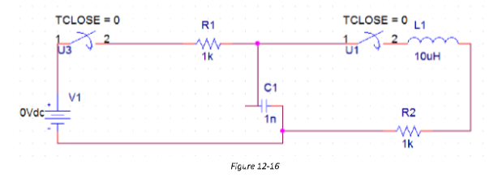

PSpice Circuit:

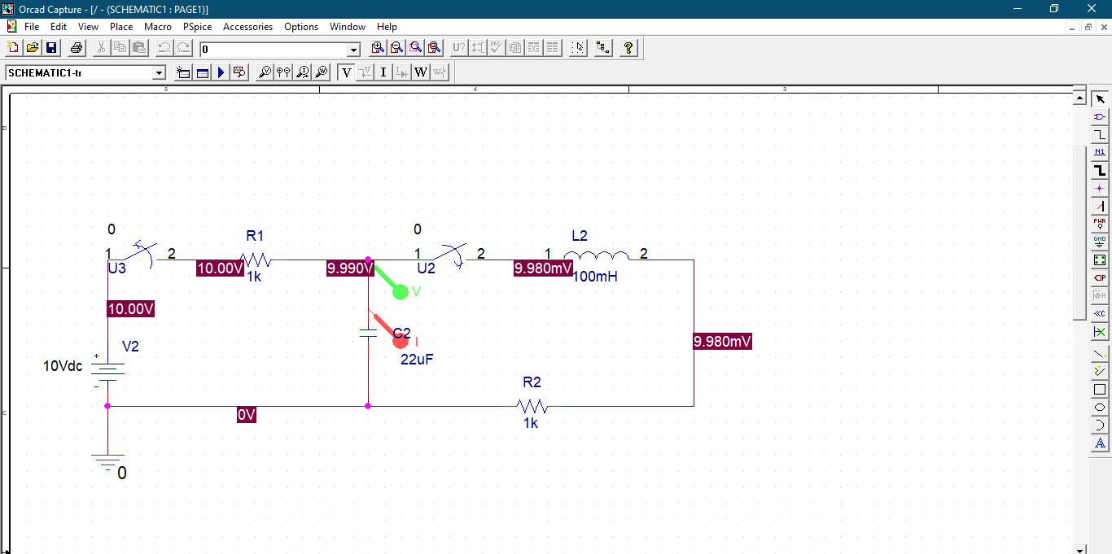

Output:

